Data Warehousing & Business Intelligence
7BUIS010W
Assessment 2

Table of Contents
Task A 2
Figure 1-Tickers List 2
Figure 2-Dataset Shape 2
Figure 3-Cleaning (Before & After) 2
Figure 4-Daily Returns 3
Figure 5-Beta Table 3
Figure 6-Volatility Table 4
Figure 7-Average Daily Returns Table 4
Figure 8-Summary Table 5
Figure 9-Graph 1 (Beta Vs Return) 5
Figure 10-Graph 2 (Volatility Distribution) 6
Data Collection and Analysis 6
Data Collection 6
Data Cleaning 6
Return Calculation 7
Beta Calculation 7
Volatility Calculation 7
Summary Metrics 7
Visual Analysis 7

Task A

Figure 1-Tickers List
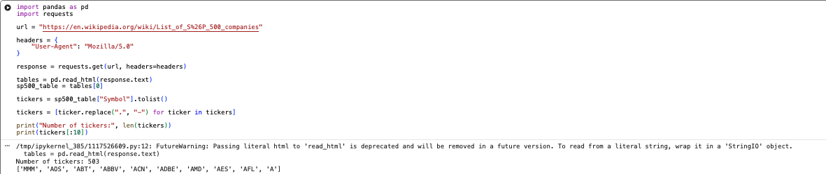
This output shows the S&P 500 companies successfully extracted from Wikipedia, providing the list of stock tickers used in the analysis.

Figure 2-Dataset Shape
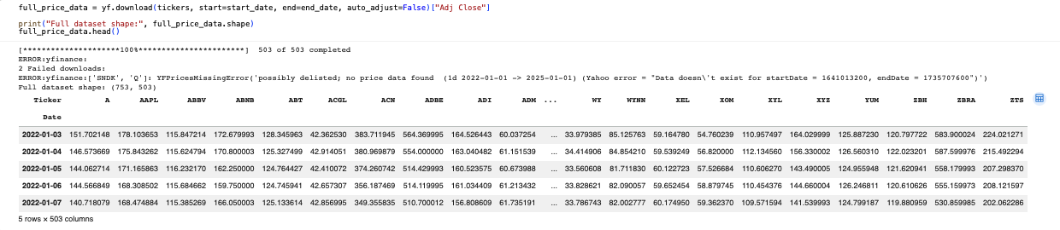
This confirms that price data was successfully downloaded for all tickers over the selected time period.

Figure 3-Cleaning (Before & After)
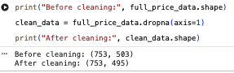
This step removes companies with missing data to ensure consistency and accuracy in subsequent calculations.

Figure 4-Daily Returns
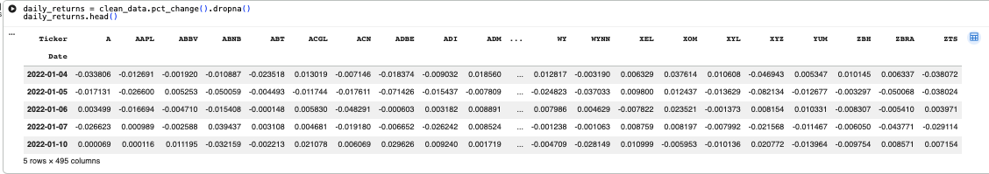
Daily returns are calculated to measure the percentage change in stock prices, forming the basis for risk and performance analysis.

Figure 5-Beta Table
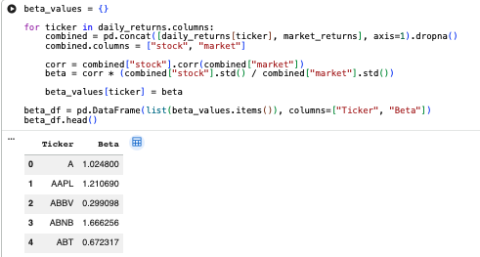
Beta values measure each stock’s sensitivity to market movements, indicating relative risk compared to the overall market.

Figure 6-Volatility Table
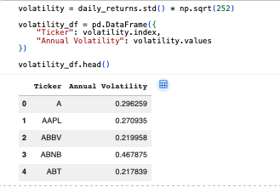
Annual volatility represents the level of risk associated with each stock, calculated from the standard deviation of returns.

Figure 7-Average Daily Returns Table
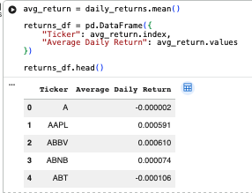
This shows the average return generated by each stock, providing a measure of overall performance.

Figure 8-Summary Table
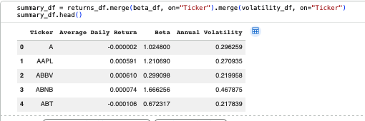
This shows the average return generated by each stock, providing a measure of overall performance.

Figure 9-Graph 1 (Beta Vs Return)
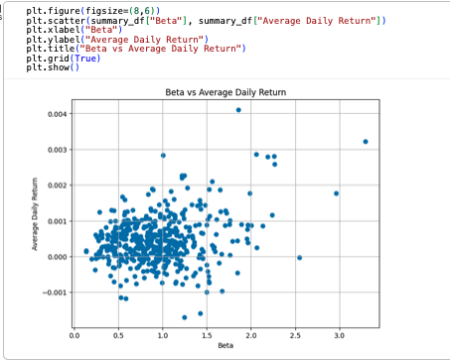This scatter plot illustrates the relationship between risk (beta) and return, helping identify whether higher risk leads to higher returns.

Figure 10-Graph 2 (Volatility Distribution)
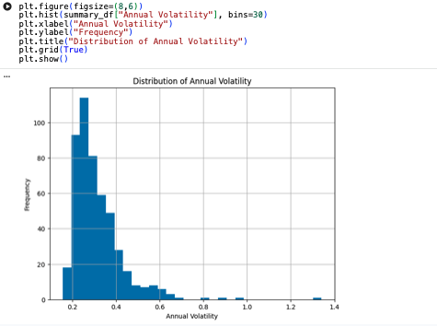

This histogram shows the distribution of stock volatility, highlighting how risk levels vary across the S&P 500.

Data Collection and Analysis

Data Collection
Stock data for S&P 500 companies was collected using Python. The list of companies was extracted from Wikipedia and processed to obtain valid stock ticker symbols. Historical price data was then downloaded using the yfinance library for the period January 2022 to January 2025.

Data Cleaning
The dataset initially contained missing values for some companies. To ensure consistency, any stocks with incomplete data were removed. This resulted in a clean dataset with fewer tickers but complete observations across the entire time period.

Return Calculation
Daily returns were calculated using percentage changes in adjusted closing prices. These returns form the foundation for analysing stock performance and risk.

Beta Calculation
Beta was calculated for each stock to measure its sensitivity to overall market movements. A higher beta indicates greater volatility relative to the market, while a lower beta suggests more stable performance.

Volatility Calculation
Volatility was calculated as the standard deviation of daily returns and annualised using the square root of 252 trading days. This provides a measure of the risk associated with each stock.

Summary Metrics
A summary dataset was created by combining average returns, beta values, and volatility. This allows for direct comparison of stocks based on both performance and risk.

Visual Analysis
Two visualisations were created to support the analysis:
- A scatter plot of beta versus average daily return shows the relationship between risk and return.
- A histogram of annual volatility illustrates the distribution of risk across the S&P 500.
These visualisations provide insight into how risk and return vary across different stocks.

